# COSC 342 Assignment 2 – Stereo Disparity Estimation

## Report for Roland Locke, ID # ID 5493858

## Introduction

The Stereo Disparity Estimation equation requires a trial-and-error process to choose the best disparity map parameters. After a precise calibration, and image rectifying process, it is almost in-elegant to guess and check what parameters will create a suitable disparity map. This duo of experiments will attempt to eliminate some of the guess work in this process by exploring a wide range of subjects on different disparity map functions and parameters.

Focusing on two functions, Stereo Block Matching and Stereo Semi-global Block Matching both provided by OpenCV version 4.8.0, this experiment generates disparity maps each with a unique combination of Block Size and Max Disparities values. Then uses these results to compare the values effect on the generated disparity maps. The goal of both experiments is to find a set of values for these to work on any subject type or distance. It’s expected that neither of these experiments will reveal a perfect value for Block Size and Max Disparities. Yet they might produce a range of values that are suitable for the diverse subject types mentioned above.

Measurement in both experiments came down purely to the author’s judgement, no instrument or program was used to evaluate the results. Comparing the generated disparity maps by eye determined the best fit values for each image. Across both experiments, the data used were images captured on a stereo camera. The functions used to create the disparity maps were calibrated for this camera and remain the same for each image pair used. Image pairs attempt to cover many different scenarios: close and far subjects, different textured surfaces, and even fur and flowers.

## Experiment 1: Block Matching

The goal of this experiment is to mitigate the trial and error of choosing the Block Size and Max Disparity for a set of images when performing block matching. Is it possible to find Block Size and Max Disparity values that can be used to produce a suitable disparity map for any subject?

This experiment was carried out by producing many disparity maps with a wide range of values. The quality of each disparity map was determined by the author, purely based on the grayscale disparity map generated by OpenCV’s Stereo Block Matching algorithm. The author attempted to determine which settings created a disparity map that most accurately represented the depth perceived in the original image and contained the least noise or missing values. Each disparity map was compared visually to its stereo pair of images as well as against the many other generated disparity maps. The Block Size and Max Disparity of the most accurate disparity maps were recorded. Again, it’s important to note that often two disparity maps were similar with near imperceptible differences, it came down to the author’s judgement to determine which appeared the best representation of the physical world.

### Results:

The best disparity map values for each image pair were recorded and can be seen displayed in *figure 1*. Max Disparity ranges from 32 to 112 while the Block Size ranges from 11 to 25. *Figure 2* Displays the information from *Figure 1* as a scatter plot to focus on the relationship between Max Disparity Value and Block Size.

|  |  |  |
| --- | --- | --- |
| Best Fit Value for the Given Image Pair (Stereo BM) | | |
| Image Pair Subject | Max Disparity | Block Size |
| Archway | 32 | 23 |
| Bark | 96 | 11 |
| Bell | 64 | 21 |
| Bookshelf | 112 | 25 |
| Cat | 112 | 19 |
| Desktop | 96 | 17 |
| Flowers | 80 | 23 |
| Hallway | 64 | 21 |
| Rock | 64 | 23 |

Figure 1

Figure 2

*Figure 3* displays disparity maps of the Hallway image pair subject with Block Sizes of 21 and a range of Max Disparity values from 16 to 128, as well as the original stereo image. *Figure 4* displays disparity maps of the Rock image pair subject with Block Sizes of 23 and a range of Max Disparity values from 16 to 128, as well as the original stereo image. These same images were used to determine the data collected in *Figure 1* and *Figure 2.*

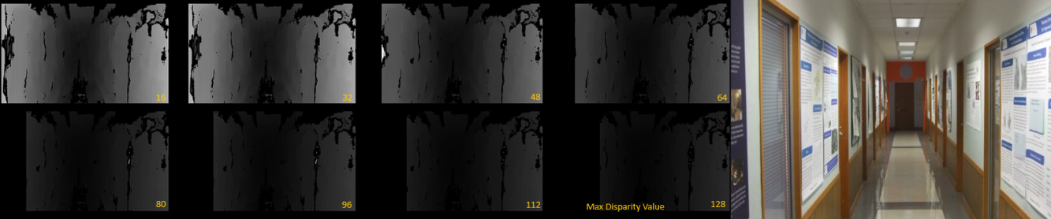

Block Size: 21

Figure 3

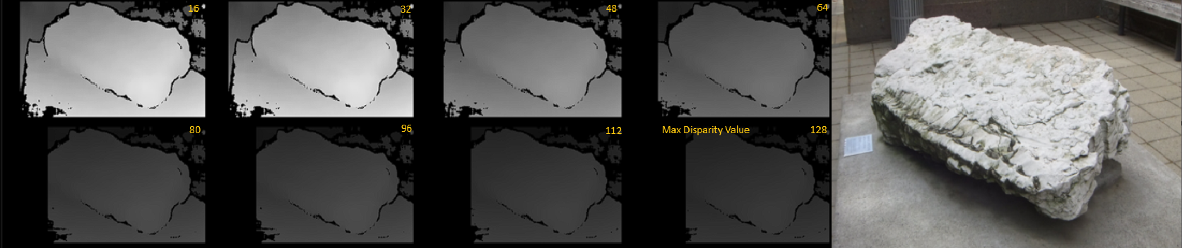

Block Size: 23

Figure 4

*Figure 5* displays disparity maps of the Cat image pair subject with Block Sizes of 19 and a range of disparity values from 16 to 256, as well as the original stereo image.

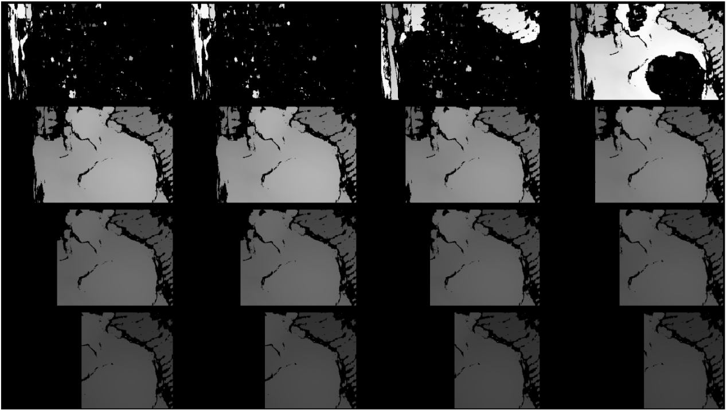

Max Disparity Value

Block Size: 19

32

16

48

192

64

144

176

224

208

160

240

256

128

112

96

80

Figure 5

Although the goal of the experiment was to come up with a pair of values that would work in almost any situation, the variance of the image subjects’ texture and distances complicated the process. As seen in *Figure 2* the range of Max Disparity values and Block Sizes lay in a large range of values. This is clear when comparing the Hallway, Rock and Cat examples in *Figures 3 4* and *5* respectively. The Max Disparity value chosen in the Rock example (*Figure 4*) creates massive holes in the Cat example (*figure 5*). In fact, disparity maps with Block Sizes from 16 to 64 in the Cat example are indiscernible while they are some of the best maps in the Rock examples.

Though inconclusive, knowing that these pictures were tested on a diverse set of subjects, this data can aid in quickly choosing settings that work among a wide range of scenarios. F*igure 2* provides a convenient way to access values of which Max Disparity and Block Size generally land.

## Experiment 2: Semi-global Block Matching

The goal of this experiment is to mitigate the trial and error of choosing the Block Size and Max Disparity for a set of images when performing Semi-Global Block Matching. Are there a set of Block Size and Max Disparity values that can be used to produce a suitable disparity map for any subject?

This experiment uses OpenCV version 4.8.0’s implementation of Semi-global Block Matching. The Max Disparity values being tested ranged from 16 to 256 and Block Size ranges from 3 to 11. The Block Size value range differ than the Block Matching experiment value range as 3-11 is the recommended range of values provided by the Open CV documentation. Semi-Global Block Matching includes many other parameters that were not tested in the scope of this experiment. In this experiment, these values were selected via OpenCV’s recommended values, which are listed as follows in the documentation: P1 = 100, P2 = 1000, disp12MaxDiff = 1, preFilterCap = 0, uniquenessRatio = 5, speckleWindowSize = 400, speckleRange = 200, mode = StereoBinarySGBM::MODE_SGBM.

In this experiment the author decided which disparity map most accurately represented the depth perceived in the original image while minimizing noise and missing values. Each disparity map was compared visually to its stereo pair of images and other disparity maps of different values. The Block Size and Max Disparity of the most accurate disparity maps were recorded. The decision of best disparity map was determined by the author’s best judgement.

### Results:

The best disparity map values were recorded for each image pair and are displayed in *figure 6*. Max Disparity ranges from 32 to 176 while the Block Size ranges from 3 to 11. *Figure 7* Displays the information from *Figure 1* as a scatter plot, focusing on the relationship between Max Disparity Value and Block Size.

|  |  |  |
| --- | --- | --- |
| Best Fit Value for the Given Image Pair (StereoSGBM) | | |
|  | Max Disparity | Block Size |
| Archway | 32 | 5 |
| Bark | 64 | 3 |
| Bell | 32 | 5 |
| Bookshelf | 128 | 11 |
| Cat | 128 | 11 |
| Desktop | 176 | 11 |
| Flowers | 96 | 5 |
| Hallway | 48 | 3 |
| Rock | 48 | 9 |

Figure 6

Figure 7

*Figure 8* shows four disparity maps of the Bark image pair each with a disparity value of 64 and Block Sizes from 3-9. Also included in figure 8 is one image from the bark image pair.

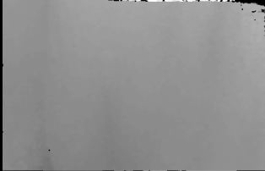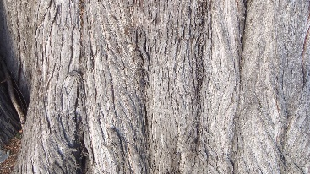

64

64

64

7

9

5

Max Disparity Value 64

Block Size: 3

Figure 8

*Figure 9* displays the Desktop image pair disparity map generated with a Block Size of 19 and Max Disparity values from 16-256 as well as one image from the Desktop Image pair.

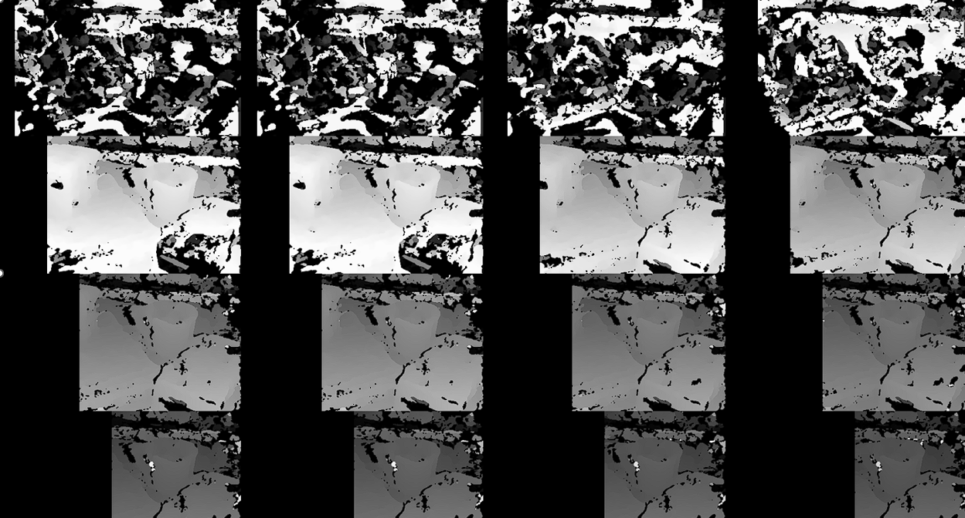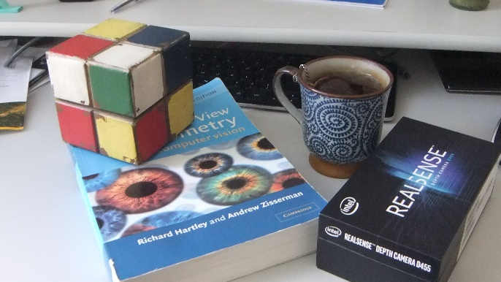

16

32

48

64

Block Size: 19

Max Disparity Value

208

256

192

128

240

176

112

224

160

96

80

144

Figure 9

Semi-Global Block Matching appeared to often generate a complete map whose values appeared very similar both across Block Sizes and across Max Disparity values.. *Figure 8* displays the depth map generated via the bark image pair. The zones on the disparity map clearly mark the changes in topography on the tree’s surface. Yet, there wasn’t much change in the topography estimation across the different Block Sizes. Thus, there was much inconclusively in determining the best values for a given image.

The results for Semi-Global matching Block Size values lie in a smaller range than that of the Block Matching results. However, the range of Block Size being tested in this experiment was also reduced compared to the block matching experiment. The range of Max Disparity falls very close to the range seen in the Block Matching Example.

Some disparity maps didn’t perform very well with any range of values. *Figure 9* shows the disparity maps for the Desktop image pair. No matter the Disparity Value or Block Size value there were no image maps for the Desktop example that did not contain the noise seen present around the cup and box in the disparity map. This might be avoided by adjusting other Semi-global Block Matching parameters, but from this data we can conclude that although no two values produce satisfactory results across the subjects, there are a range of values that can be picked to fit a large range of scenarios.

## Final Remarks

The work performed in this experiment only covered the Stereo Disparity Map function. Yet, there are many steps that influence the results of disparity map Estimation process. Functions such as Calibration, Rectification, and Resizing all have influence in the results and are performed before the Disparity Estimation Process. Future experiments should include tests on these functions in the testing process. As for the OpenCV Stereo Semi-Global Block Matching function specifically, the function also accepts many other variables that haven’t been considered among this series of tests.

The images taken for these experiments were of diverse subjects but provided little repetition needed determine what parameters worked best overall for each subject type. Multiple angles at equal distance of the same subject would aid in identifying a range of values that work best for a given lighting and subject type (ie: furry, flat, bumpy). Similarly, multiple distances at the same angle would help further narrow down each range of values.

Although both experiments failed in producing a conclusive set of values for each mapping function, it did produce data that can be used to choose a range of values for many subject distances and types (see *figures 7,6,2,1*). Though, these values don’t promise to produce a perfect result either and should only be used as a starting point in the disparity map generation. Hopefully eliminating the majority of trial and error involved in the process. Perhaps the most useful thing to come from this experiment was the tool created to compare the wide variety of Block Sizes and Max Disparities. In fact, a user looking to find the best values for a given image pair should use this tool to quickly browse through the disparity maps and select the best map result. That would both quicken the process for the user and create the most complete set of results.